AttendLogServer Sample Program Usage Guide

# How to run the application

## Running the application from Visual Studio

Open the solution ( CsWebSDK.sln ) from Visual Studio, open the AttendLogServer project properties, and configure the debug settings as follows.

(VS2022)

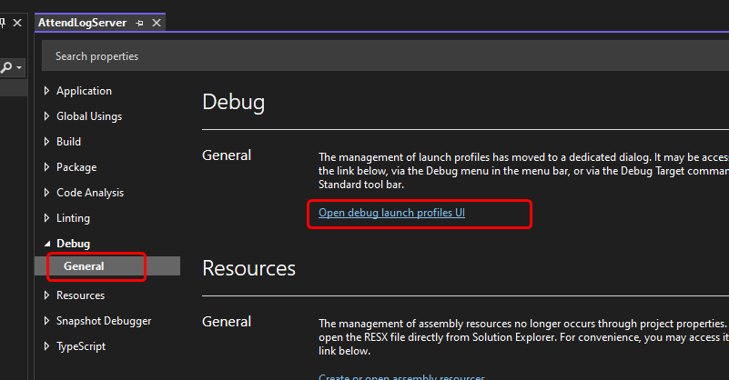

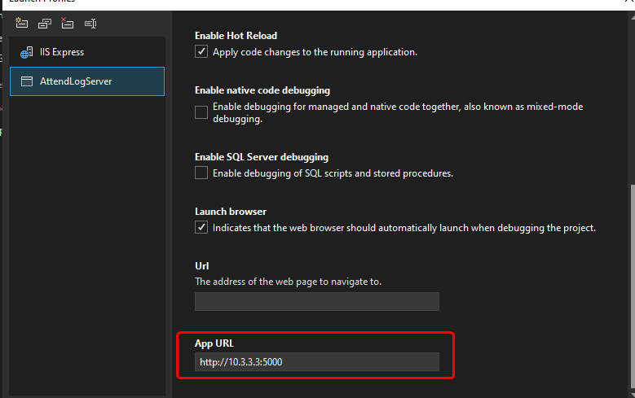

(VS2019)

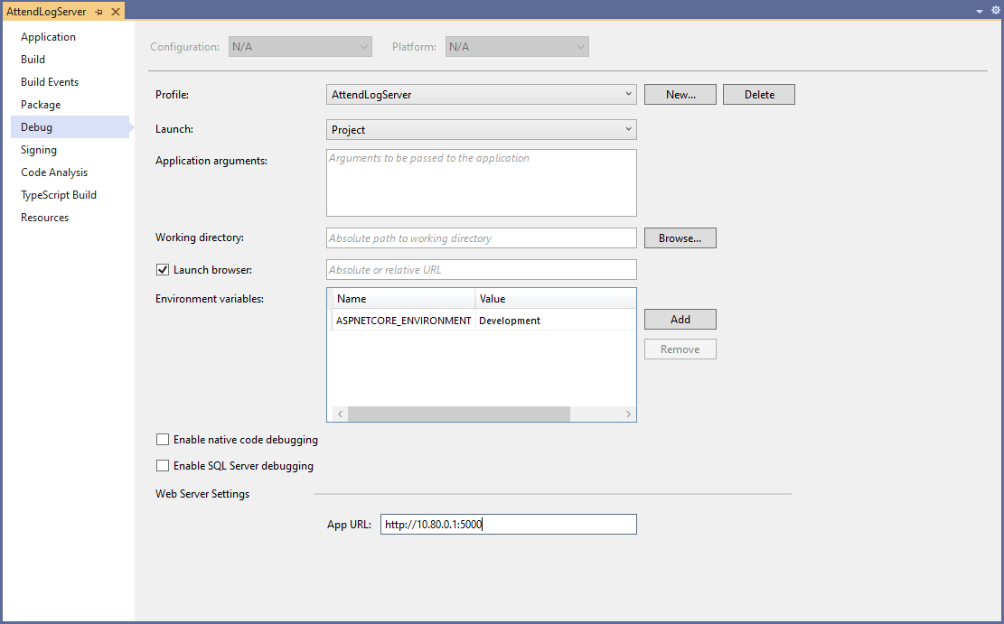

Important settings

* Launch : Select Project .
* App URL : Set it to http://computer IP address:port number

Then, run the project.

## Running the Application on IIS

Please refer to <https://learn.microsoft.com/en-us/aspnet/core/host-and-deploy/iis/?view=aspnetcore-9.0> .

# Adding a device in the application

Open the application URL, select the Devices tab, and click the Register a Device link.

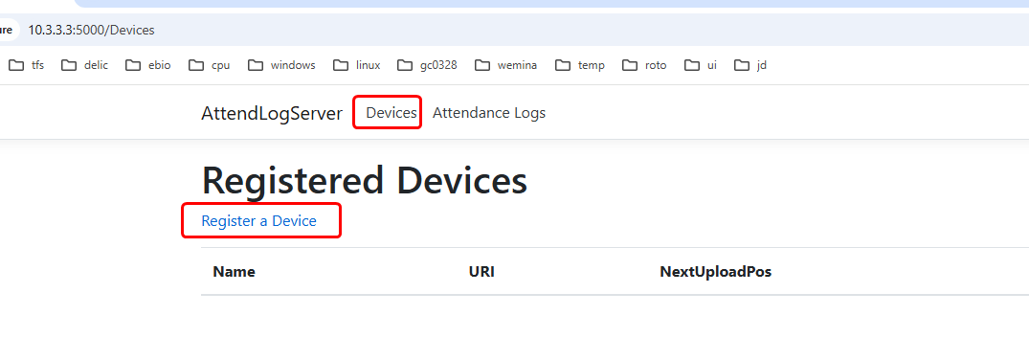

Enter a device name (used only in the app), modify the API key if needed (you can leave it at its default randomly generated value), and click the Register button.

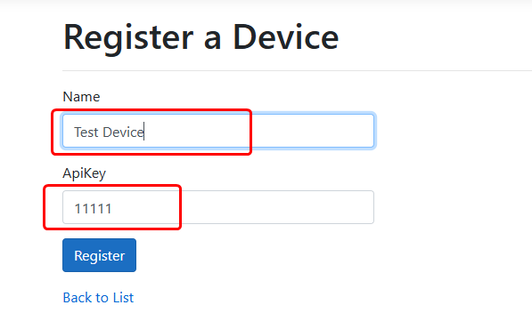

# Configure the URL for uploading attendance records to the device

After registering a device, you can find its upload URL from the Devices tab.

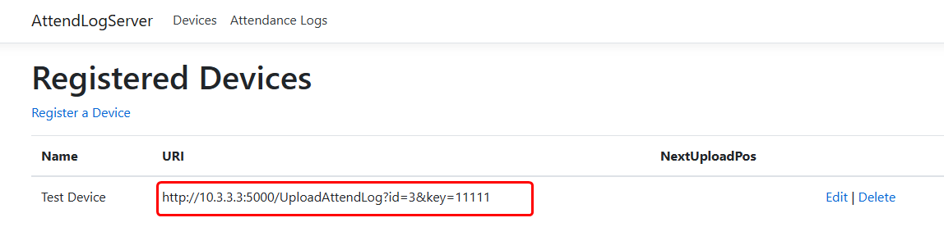

Use the SDKDemoApp application to configure the device's attendance record upload URL.

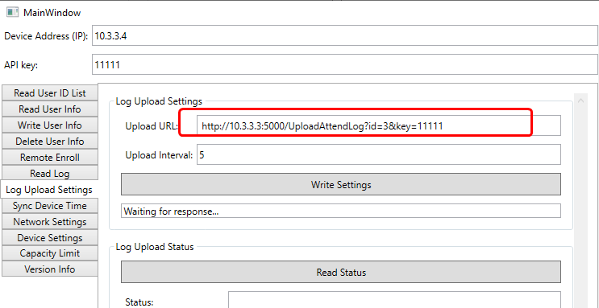

# View attendance records

Open the application URL and select the Attendance Logs tab.

# HTTPS Configuration

Please refer to <https://learn.microsoft.com/en-us/iis/manage/configuring-security/how-to-set-up-ssl-on-iis>.